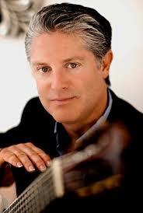
Lito Romero is a member of the renowned ensemble Los Romeros Guitar Quartet, and an internationally acclaimed soloist. He is the grandson of Romero patriarch Celedonio Romero and the son of legendary guitarist Angel Romero. For 20 years Lito Romero has been dazzling countless audiences with his guitar virtuosity and brilliant technique. He has played in such prestigious theaters as Carnegie Hall in New York, Concertgebouw in Amsterdam and the Bellas Artes in Mexico City, and regularly tours throughout Europe, South America and Asia. He has been featured in the KPBS/PBS biographical documentary “Los Romeros—The Royal Family of The Guitar”. Lito is currently blazing new solo trails with his own brand of contemporary guitar-based music. Implementing hip-hop and pop beats, mixing in lush synth sounds, and overlaying provocative Flamenco-inspired melodies with guitar and voice, Lito draws from his rich Spanish heritage while staying true to his love of classic popular song to foster a whole new musical experience.

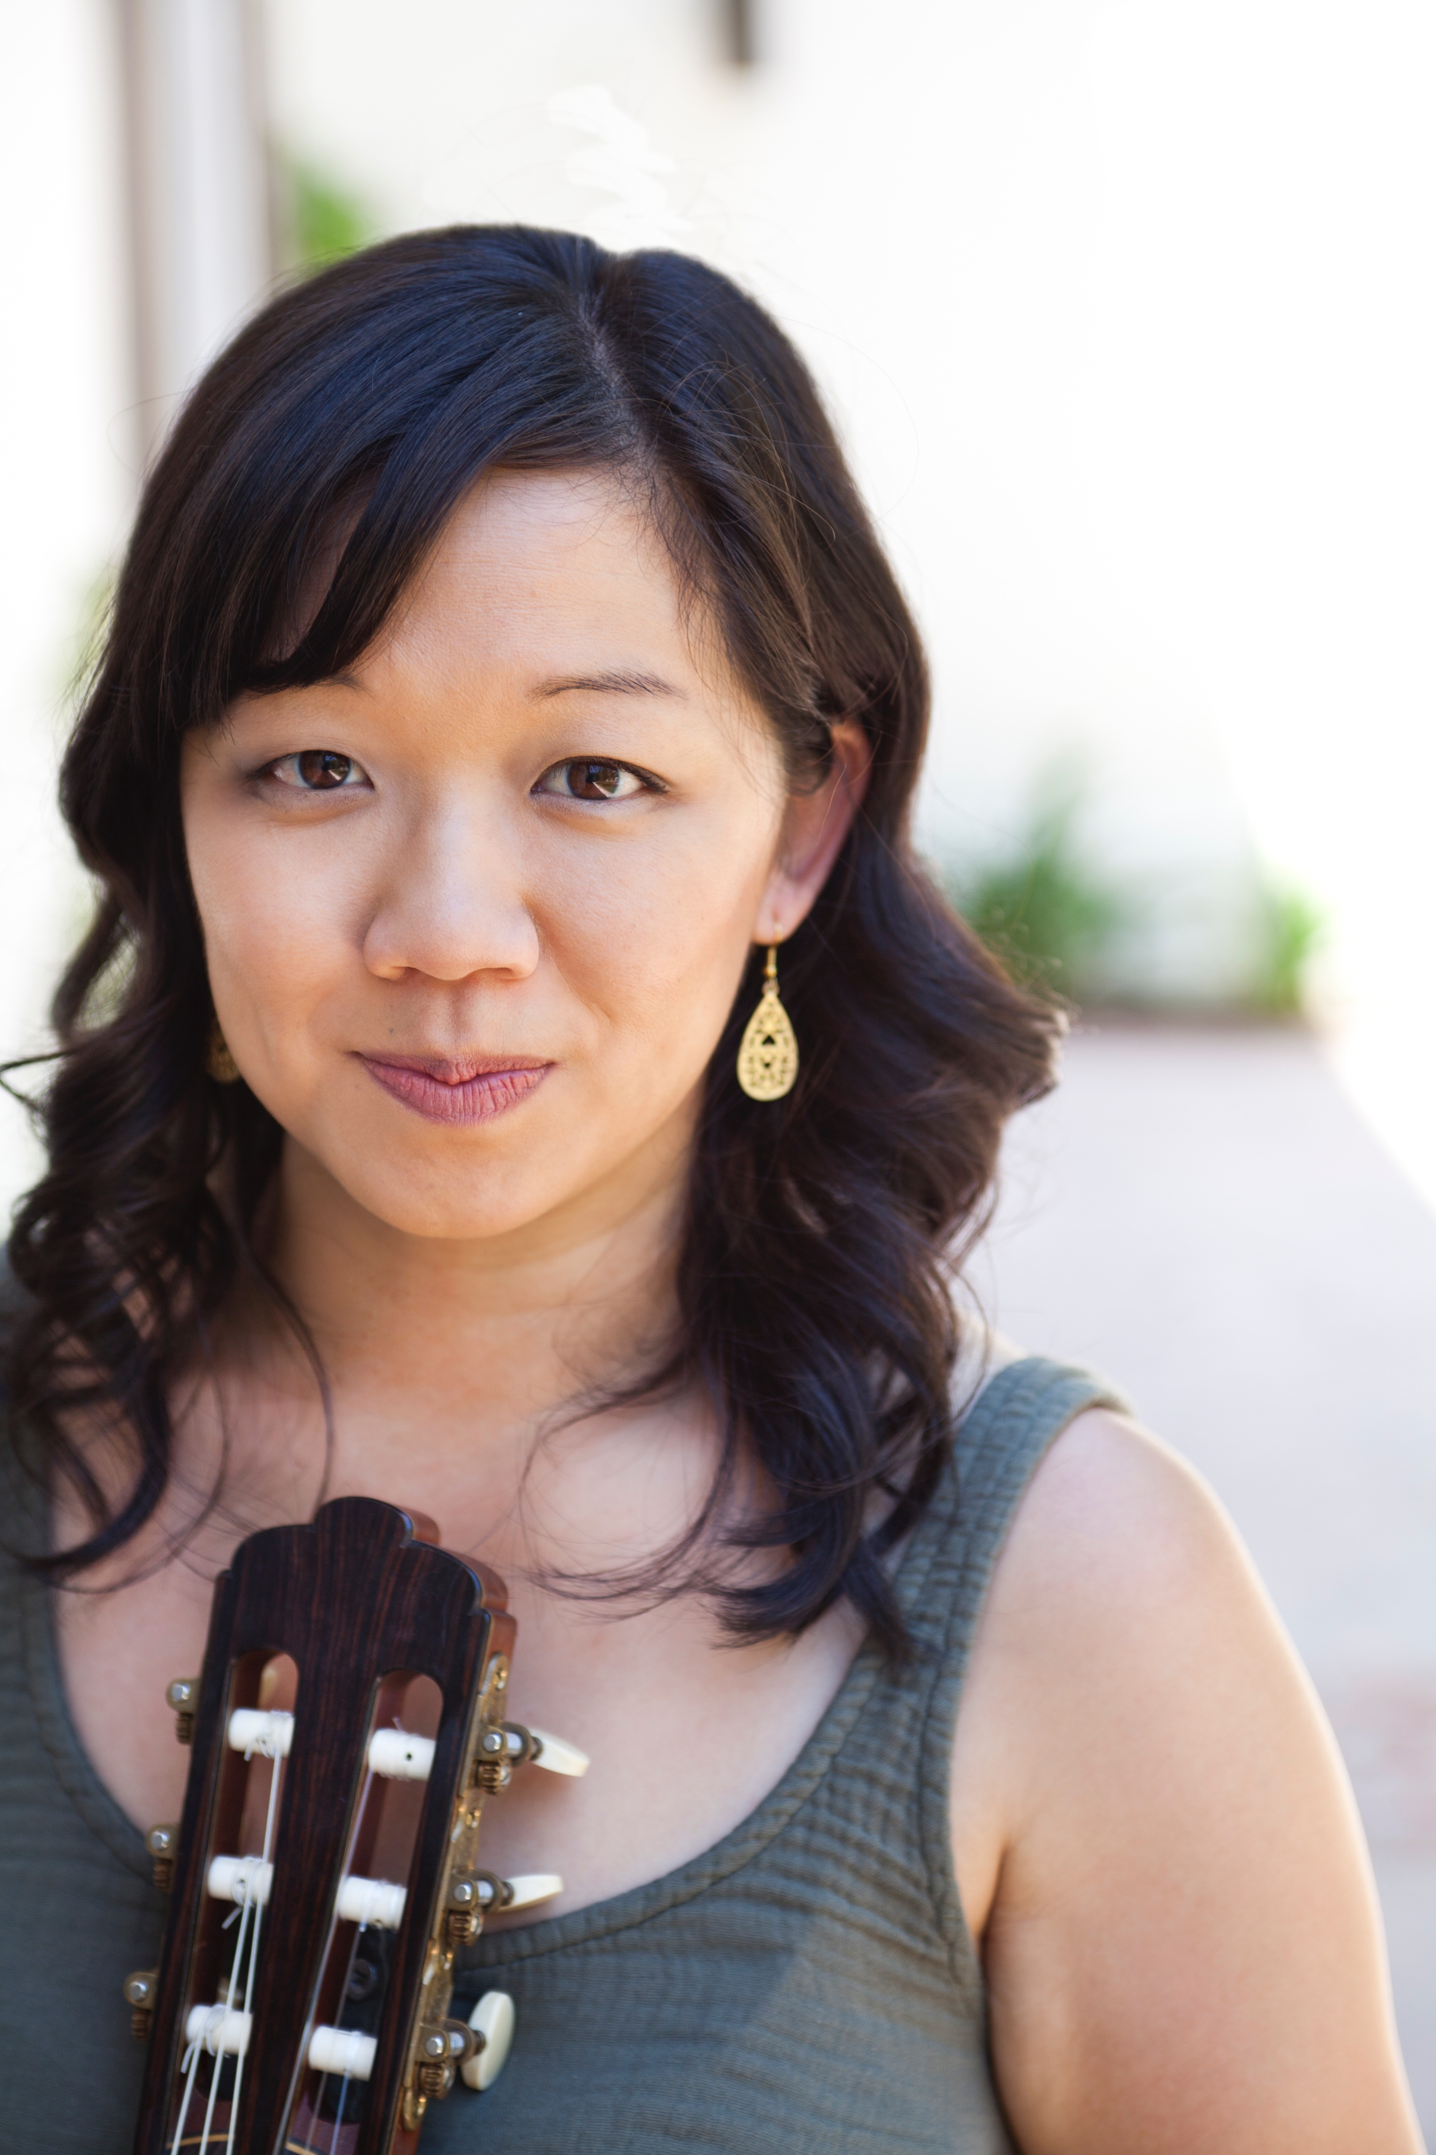
Dr. Connie Sheu is a dynamic guitarist, devoted teacher, and ardent advocate of classical guitar. She is a frequent performer as both a soloist and chamber musician on various concert series and music festivals throughout the country. Dr. Sheu studied U.S. History and Music at Columbia University and earned a Master of Music from the Juilliard School. She completed her Doctorate of Musical Arts at the University of Southern California. Dr. Sheu is General Manager for the Guitar Foundation of America and teaches at the Colburn School, Vanguard University, and online with Classical Guitar Corner.

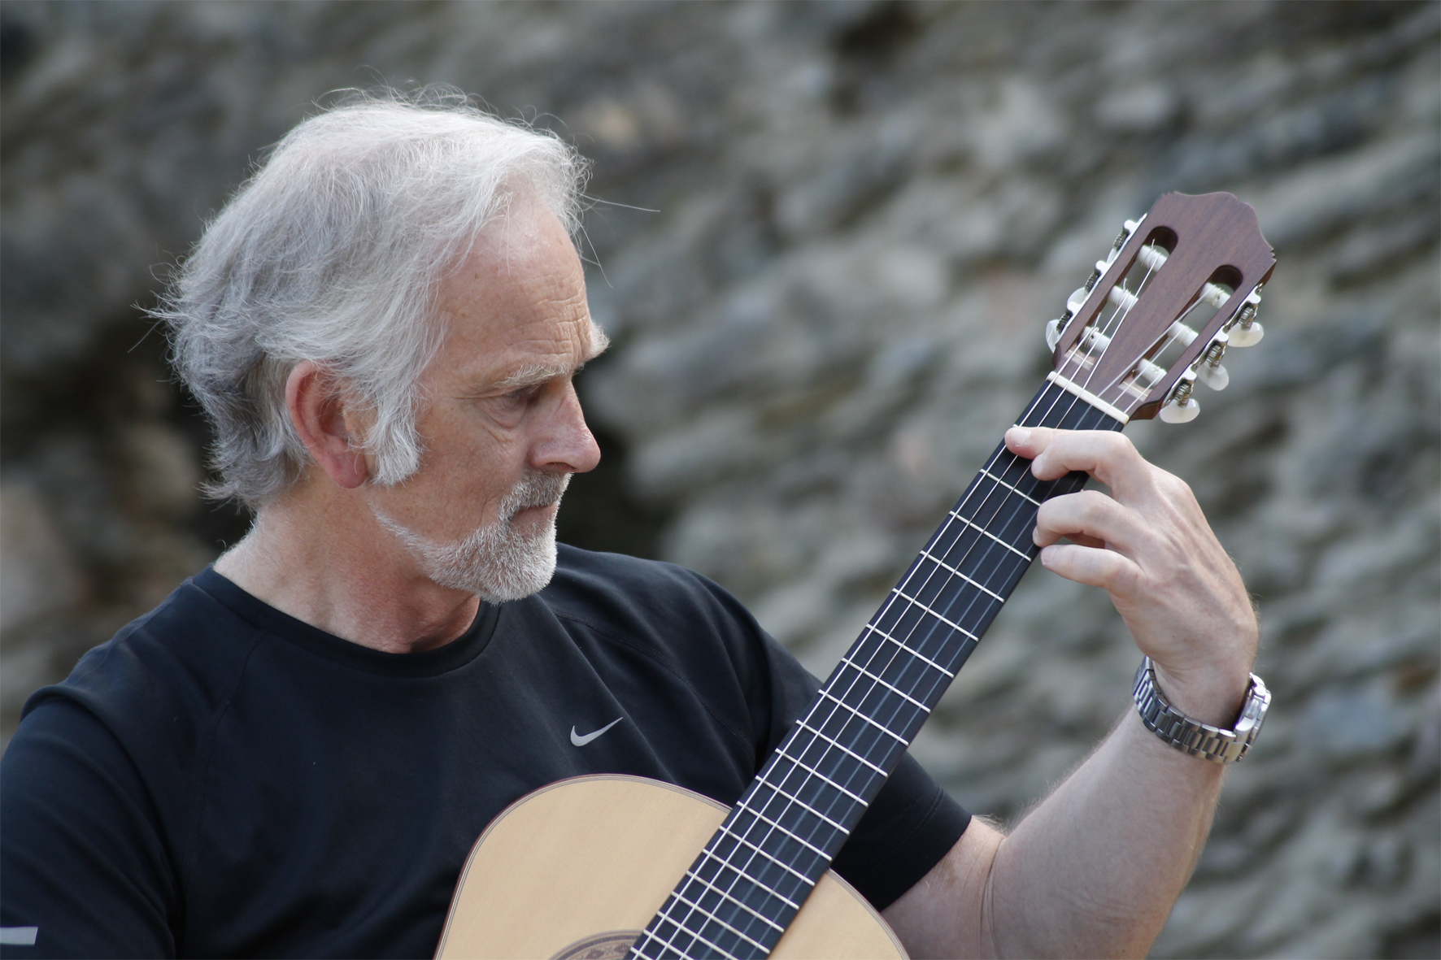
Norwegian composer/guitarist Gisle Krogseth has been highly active in both principal aspects of his career. As a performer, he tours throughout Europe and in the United States. Unusually versatile as a composer, he has written symphonic music, chamber music, choral music, musical theatre and cabaret. He has recorded many CDs, done Radio and TV-performances, composed for film and TV, and published his music in Norway, USA, Italy, Scandinavia, Russia, Serbia, Bulgaria and England. In 1991 he represented Norway at the World Festival for Theatre. His solo CD Il Canto del Mare was released in Italy and Japan in December 2014, and his Viking Concerto appeared on the label “Brilliant Classics” in April 2015.

Jack Van Zandt (b. 1954) is a veteran composer of music for concerts, television, film, and multimedia installations. He studied composition with Alexander Goehr, Thea Musgrave, Peter Maxwell Davies and Peter Racine Fricker. He is also a teacher, music education program designer, concert curator and producer, and frequent lecturer on various musical subjects. He was Visiting Artist at Cal Arts in 2017. He has recently received commissions from the Copland House Foundation, Hear Now, Grammy-nominated pianist Nadia Shpachenko, the Cal Poly Pomona Piano Ensemble, the Villiers Quartet (UK), cellist Maksim Velichkin, Celliola, LA Harptette, bass-baritone Nicholas Isherwood, and soprano Stacey Fraser. He is a board member of the Los Angeles branch of the American Composers Forum, of which he was president 2014-17.

Praised for her “intensely focused” playing by The New York Times, violinist, pedagogue, and recording artist Patti Kilroy is a uniquely modern-minded musician, most known for both giving the world-premiere to over 100 works, with a particular focus on looping, live processing electronics, and prepared violin. Based in Los Angeles, she is an Assistant Professor in the Department of Music at California State University, Los Angeles, and has served as faculty at Western Connecticut State University, New York University, and CUNY Hunter College. To learn more about her career engagements or research interests, visit pattikilroy.com.

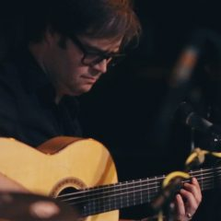
Kai Narezo is a flamenco guitarist who has always had one foot planted in the Old World and the other in the New. His sound reflects a deep reverence for the roots and the soul of traditional flamenco, a love for the modern flamenco landscape, and an American sensibility rooted in jazz-fusion and contemporary production techniques. His first album, Vueltas, was released in 2006, and his latest album, Contra Tiempo, in 2015. His co-authored textbook, Flamenco Explained: The Guitarist's Survival Guide, will be the first text ever to be used to teach flamenco at Berklee College of Music, where he also studied as a recipient of the BEST Scholarship. His work has also appeared in various film and television projects. Narezo is a brilliant soloist in high demand as an accompanist and is a dedicated and proven teacher. He holds a B.A. degree in Russian Literature from Columbia University, a Bachelor of Music from Berklee College of Music and currently resides in Los Angeles, California.

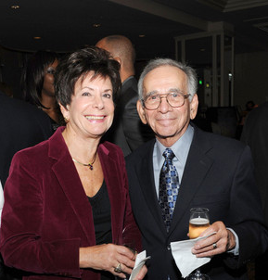
Sheldon Mehr joined the faculty at Moorpark College in 1970 where he founded and directed the Jazz Ensemble, Chamber Orchestra, Symphony Orchestra, Concert Band and Chamber Ensembles.
Mehr has composed more than fifty works for band, orchestra, voice, chamber ensembles, piano, and jazz ensembles. He is the author of two textbooks; Music Fundamentals and The Music of the Media: An Innovative Approach to Music Appreciation. His children’s book on music, Sarah P. Reinhardt’s Band was published in 2006, and The Dilemma of Harold T. Finch was published in 2010. A book of short stories, The Walls of Jericho was published in 2009, and the second book of short stories, The Buck Stops here, the same year.
He has served a guest conductor, adjudicator, lecturer and clinician and Adjudication Techniques for the Music Educators National Conference as well as the Music Association of Southern California Community Colleges.

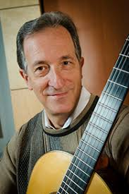
While still a student at California State University at Northridge, Jeffrey Cogan, M.A., was honored by being invited to perform for the great Spanish Maestro of the guitar, Andres Segovia. After finishing his studies, he built a career in performing and teaching the guitar at CSUN and at Chapman University.
Mr. Cogan has performed around the USA and Europe. In 1998, Cogan was invited to Perigueux, France, to perform and teach at the Ecole Brittain with the acclaimed French guitarist Olivier Chassain.
During the spring and summer of 2004, Mr. Cogan was invited to adjudicate different competitions in Austria and France. He was also a featured performer in the Fabritio Caroso guitar festival in Lanuvio, Italy. In the summer of 2005 Mr. Cogan performed a concert for the VIII Festival De Musica De Guitarra, "Villa de Aranda" in Aranda de Duero, Spain.
Mr. Cogan's work in the Conservatory of Music at Chapman University has won praise for him and his students alike. He is Director of Guitar Studies and Music Technology as well as frequent performer in many of the Conservatory of Music concerts.

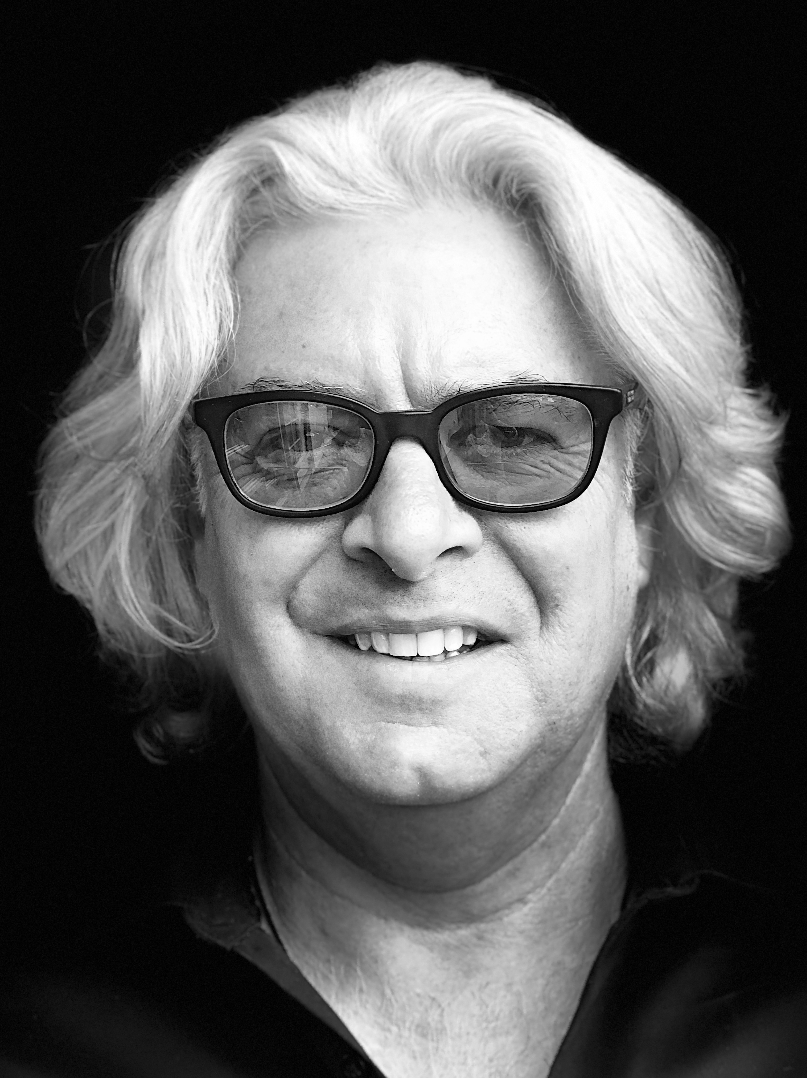
Scott Detweiler is director of New Orleans Jazz Funksemble, with whom he performs regularly, as well as solo (guitar/vocals) and as church cantor. He is a prolific arranger, lyricist and composer who studied at Loyola University and UNO and also with Henri Mancini and Ellis Marsalis. He has worked with Chamber Players of Los Angeles, members of the L.A. Philharmonic, opened for The Preservation Hall Jazz Band and Gregg Allman (and many others). Scott has released over 20 (twenty) albums under his own name, writes for other artists and is the recipient of several prestigious awards. Full bio/CV at www.detweilermusic.com

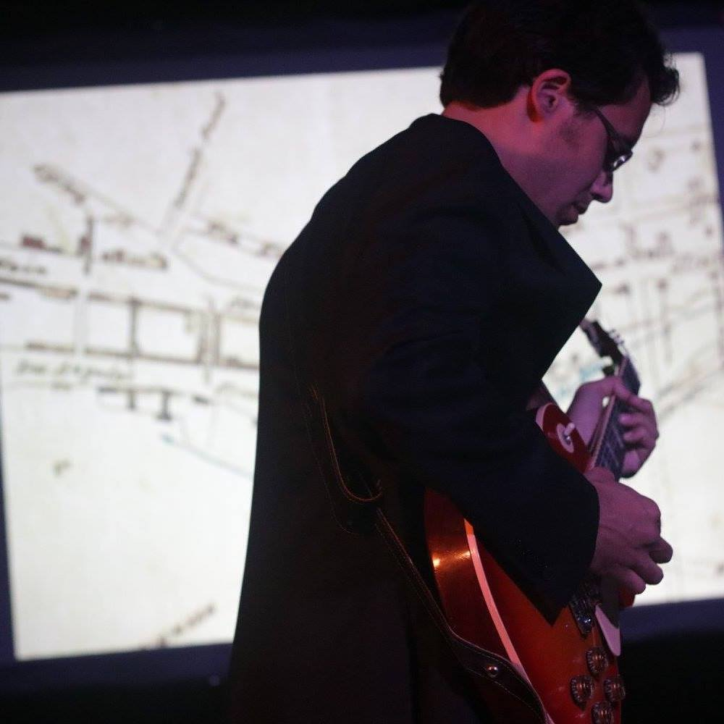
Alexander Elliott Miller is a composer and guitarist whose music has been described as "wild...unearthly...lyrical...a voice worth listening to" (San Francisco Classical Voice) and "deceptively laid back in an LA way...inventive....unconventional" (LA Times). His compositions have been performed at Carnegie Hall and London's Mile End Art Pavilion; he has collaborated with Grammy nominated musicians including pianists Vicki Ray, Aron Kallay and soprano Tony Arnold, as well as many contemporary classical ensembles and organizations such as HOCKET, Juventas New Music Ensemble, Earplay New Chamber Music, the Boston New Music Initiative, the Los Angeles Percussion Quartet, Panic Duo and Duo Montagnard among others. In the fall of 2018, his album TO….OBLIVION: Historic Landmarks Around Los Angeles was released. Miller is on the faculty of California State University Long Beach and Chapman University, where he teaches music theory and composition. www.alexanderemiller.com.

Ross Levinson began his professional career in NYC composing music for theater and dance. He worked with Tom Waits, Harry Belafonte, Joan Jett and his own band: Plan B. After moving to LA, Mr. Levinson scored the hit television series Midnight Caller and Reasonable Doubts and was nominated for an Emmy for the series Falcone. He scored the Peabody Award winning documentary, Black Sky and the Cine Award winning Finding Kalman. His violin playing has been heard on major feature films including Terminator and Fright Night. Mr. Levinson is a Professor of Music at CSULA.

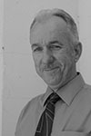
Charles Suovanen received his Bachelor’s Degree in Guitar Performance and Master’s Degree in Music from California State University, Northridge.
His primary teachers were the guitar faculty at CSUN under the leadership of Dr. Ronald Purcell. He furthered his education through master classes under the direction of Carlos Barbosa-Lima, Alirio Diaz, Elliot Fisk, Robert Guthrie, Oscar Ghiglia, John Mills, John Duarte, Alice Artz and Manuel Barrueco. In 1977, he was selected from among his classmates to perform for the great Spanish guitarist Andres Segovia.Mr. Suovanen and the other outstanding guitar faculty of LACC have developed one of the most comprehensive classical guitar programs found in any community college district in the State of California.

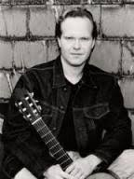
Dr. Steven Thachuk has appeared in recitals, as a chamber musician, and soloist with orchestras throughout North America, Great Britain and Europe. Dr. Thachuk has an international reputation as a leading teacher and pedagogue of the instrument. Recent performances and classes have taken place in Toronto, Nova Scotia, Kentucky, England, Germany, the Stetson International Guitar Festival, the Gevelsberg Gitarren Festival, the Iserlohn Gitarren-Symposium, the Halifax International Guitar Festival, and the Eastman Summer Guitarfest, as well as solo appearances with the Toronto Sinfonietta, the Quinte Symphony, the Prince George Symphony, and the Toronto Philharmonia.
In 2002, Dr. Thachuk was appointed as Professor of Guitar at California State University, Northridge.

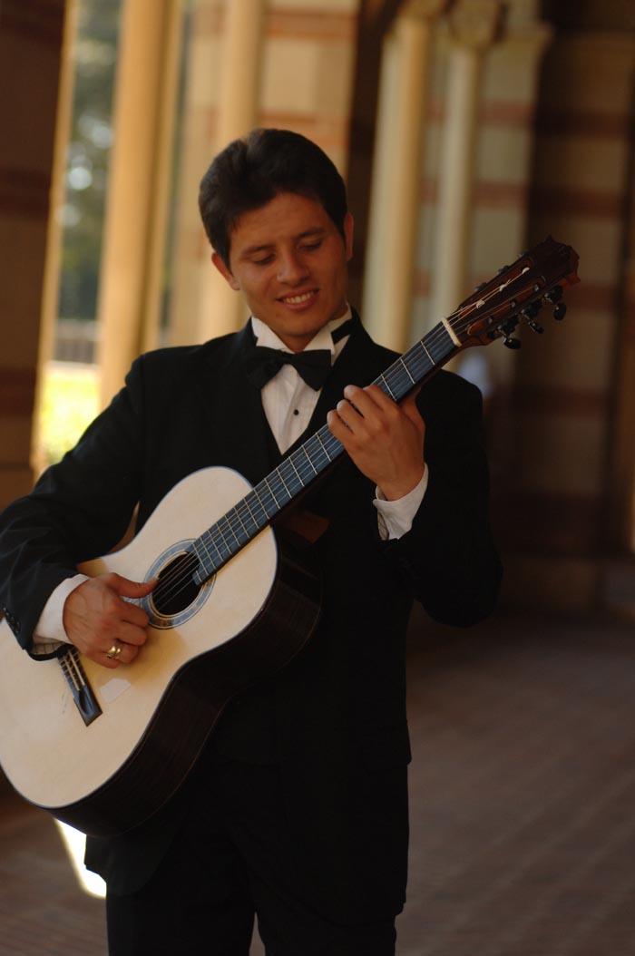
Vasil Chekardzhikov Born in 1979 in Varna, Bulgaria, Vasil endeavored the journey in music at the age of 5 learning to play the Accordion. Following the example of his brother Nikola and sister Petya, he picked up the guitar as his main instrument in 1987, and along with his twin Petar formed the youngest professional guitar quartet in the world at the time, touring Europe under professional management from 1994 until 1997 under the name of Four Of a Kind, releasing their first cd album in 1994.

He completed his MM Degree in Guitar Performance and studied orchestral conducting under Prof. Kimo Furumoto ! Currently he is a recording, and touring professional with his brothers as a member of one of the finest guitar trios on today’s stage TRIADA.

Vasil is serving on the Faculty of Encore High School of The Arts, Riverside.

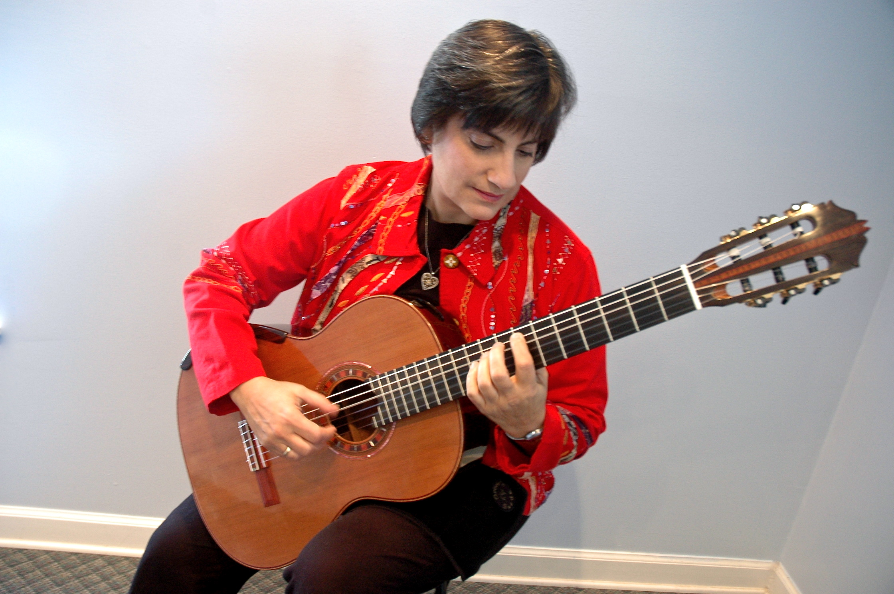
Andrea is an alumna of Berklee College of Music where she majored in jazz guitar performance and received an Outstanding Alumni Service Award. She travels internationally as a clinician and performer working with students of all ages. Recent events have taken her to Europe, Canada and Latin America.

Andrea is humbled and proud that arts advocacy group Alarte of Guatemala City, Guatemala has created a Scholarship in her name. The first recipient of the 'Beca Andrea Cannon' is enjoying the benefits of a new guitar as well as expert Suzuki Method instruction; and she also has a beautiful smile.

