# How to create a Vimeo account

*To create an account on Vimeo:*

1. Visit [vimeo.com](https://vimeo.com/), then select Join in the upper right corner.



1. Enter your name, email, and create a password.
2. Click Join with email.
   * This creation method is preferred to ensure you maintain access to your account outside of any social media account credentials and enables you to immediately take any actions needed that require a Vimeo account password (such as deleting a video).

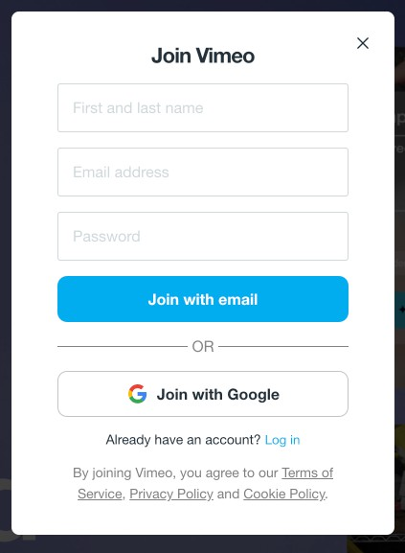

* + You can also select Join with Google to create and log into a Vimeo account via an existing Google account; follow the on-screen prompts to complete the sign-up.

1. You will be prompted to answer a few questions that will help us get to know what our customers use Vimeo for. Proceed through the survey (you can also skip it).
2. You will see the [available subscription plans.](https://help.vimeo.com/hc/en-us/articles/12425432033937-Compare-Vimeo-plans) You can start a trial, purchase a plan immediately, or click 'No thanks' to proceed with a Free account. You can always upgrade later.
3. Finally, be sure to check your inbox to verify your email address.

# How to upload a video to Vimeo

*To get started with Vimeo, one of the first steps you can take is to upload a new video.*

*To upload a video:*

1. Select **New** on the top right of the page, then select **Upload.**

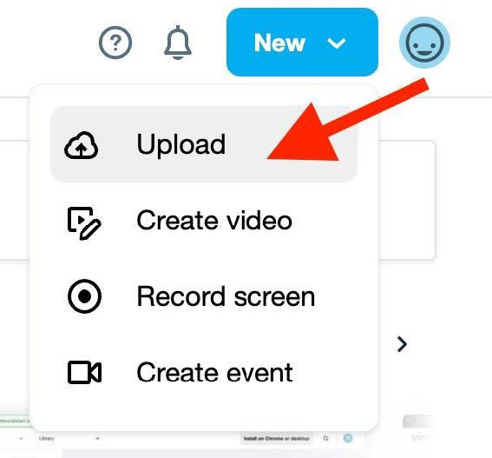

1. On the Upload page, you can select various ways to upload a video.
   * *To upload a video that is saved on your computer, you can select Choose files.*

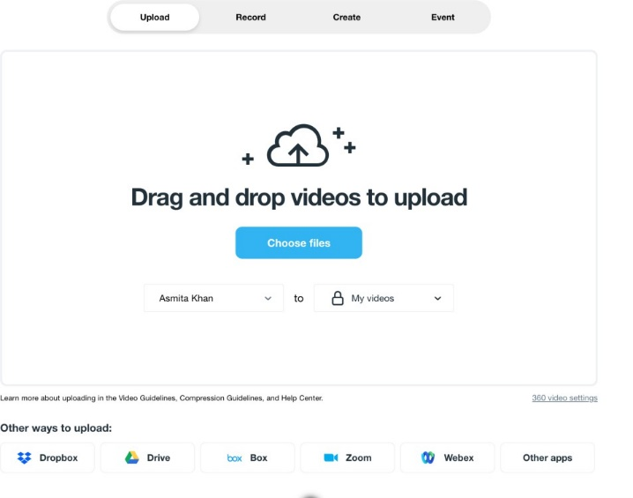

1. You can select where in your library the newly uploaded video will be saved.

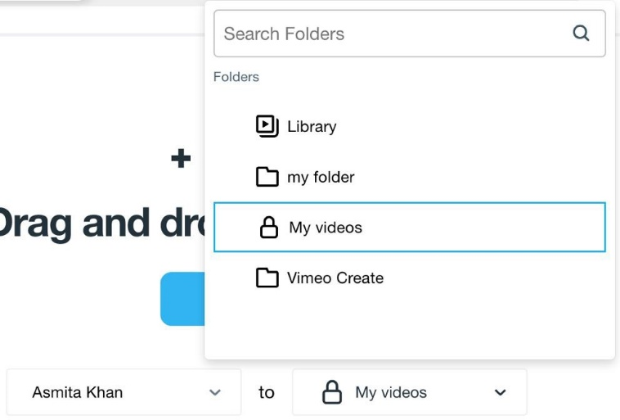

1. Once you select the destination folder and select the file to be uploaded, it will upload automatically.
2. After your video is uploaded, you will be taken to the video settings page. To know more about the different privacy settings, refer [How to change your video's privacy settings](https://help.vimeo.com/hc/en-us/articles/13806764653201-How-to-change-your-video-s-privacy-settings)

You can also use the Record, Create, or Event function on the Upload page to create and add content to your Vimeo account.

**Note:** The number of videos you can upload will vary depending on your membership plan.

*Refer to* [*How to purchase a subscription*](https://help.vimeo.com/hc/en-us/articles/18686705948433-How-to-purchase-a-Vimeo-subscription) *for more information on purchases and various membership plans.*