# WEBINAR PLANNING FORM

1. First submit the webinar license request form.

Located on the ITS webpage: [Webinar License Request Form](https://calstatela.service-now.com/now/nav/ui/classic/params/target/com.glideapp.servicecatalog_cat_item_view.do%3Fv%3D1%26sysparm_id%3Da271fba51b9020506c0bc99f1d4bcbe2%26sysparm_link_parent%3D29f13741135d1700821150622244b0b8%26sysparm_catalog%3De0d08b13c3330100c8b837659bba8fb4%26sysparm_catalog_view%3Dcatalog_default%26sysparm_view%3Dcatalog_default)

1. After the Webinar License Request Form is approved log into [**MyCalStateLA**](https://csula.sharepoint.com/sites/MyCalStateLA)portal.
2. Go to the Zoom platform under **SOFTWARE AND TOOLS**.

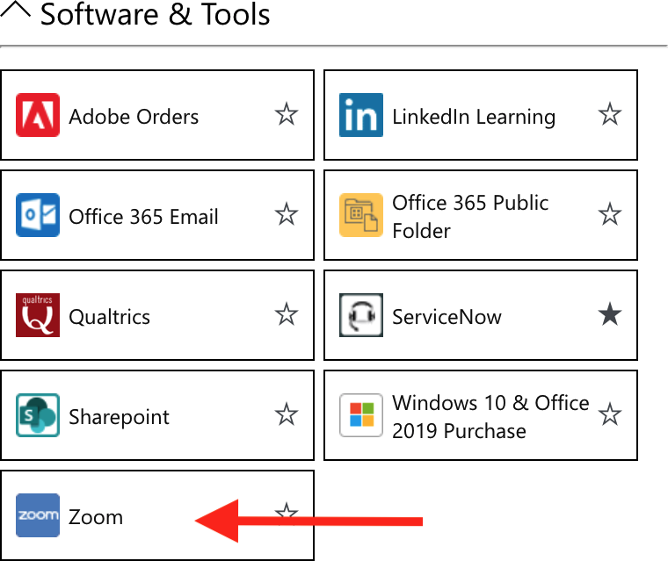

1. Once it is approved it will show up in your Zoom account on the Left. This is where you can schedule the webinar.

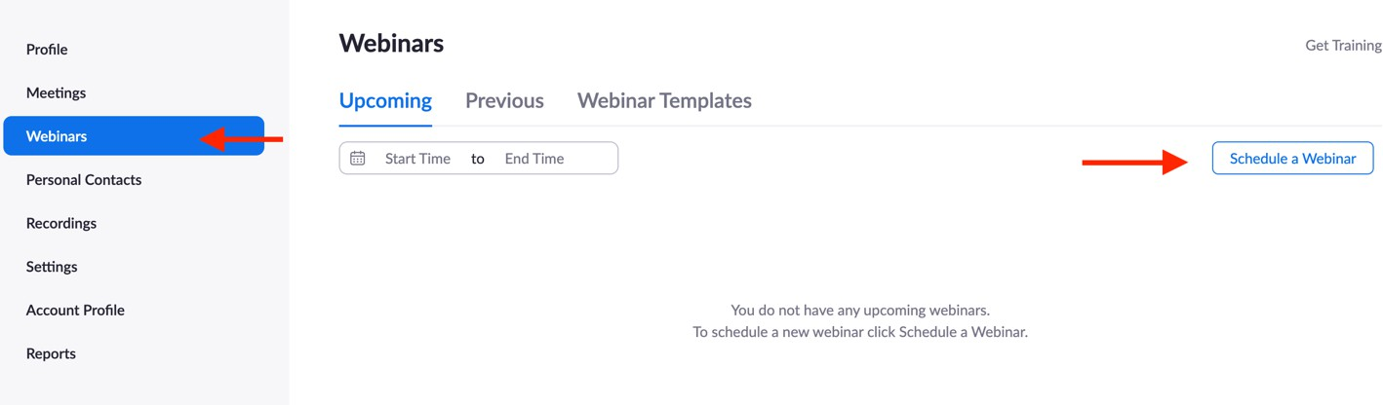

## Additional Resources:

[Watch tutorial on how to schedule webinar with registration.](https://support.zoom.us/hc/en-us/articles/204619915-Scheduling-a-webinar-with-registration)

[Roles in a webinar](https://support.zoom.us/hc/en-us/articles/360000252726-Roles-in-a-webinar)

[Spotlight feature](https://support.zoom.us/hc/en-us/articles/201362653)

## Submit Live Captions Request via the accessibility department:

[SUBMIT LIVE CAPTION REQUEST](https://calstatela.service-now.com/now/nav/ui/classic/params/target/com.glideapp.servicecatalog_cat_item_view.do%3Fv%3D1%26sysparm_id%3D48288c4edbdcd0108f811d03399619e3%26sysparm_link_parent%3D9e8f33341b7b0410065fa9722a4bcbfe%26sysparm_catalog%3De0d08b13c3330100c8b837659bba8fb4%26sysparm_catalog_view%3Dcatalog_default%26sysparm_view%3Dcatalog_default)

## WEBINAR PLANNING FORM

|  |  |  |  |  |  |
| --- | --- | --- | --- | --- | --- |
| **Webinar Name:** | | | | | **Event Date:** |
| **Start Time:** | **End Time:** | **Tech Team Log in:** | **Panelist Log In:** | **Rehearsal Date:** | **Rehearsal Time:** |

| **\*Tech Team:** | **Names:** | **Duties:** [***\*Roles in Webinar***](https://support.zoom.us/hc/en-us/articles/360000252726-Roles-in-a-webinar) |
| --- | --- | --- |
| **HOST:** |  | Start/Ends Webinar, ASSIGNS LIVE CAPTIONS, RECORDS. |
| **Co-Host:** |  | Screen Share – Beg/ending slides, Power Point, Video * etc.  **\*Will you be screening a video? Yes No** |
| **Co-Host:** |  | Spotlights Guest (*Need 3 participants with video* ***ON*** *and can be managed by* ***host, or co-host****)* |
| **Co-Host:** |  | Manages audio - **MUTE/UNMUTE** when necessary |
| **Co-Host:** |  | Cues guest to **TURN ON/OFF** camera. |
| **Co-Host:** |  | Monitors the **Q&A** |
| **Co-Host:** |  | Other Duties |
| **Co-Host:** |  | Other Duties: |

| **Guests Names:** | | **Log in Time:** | **Sharing Materials:** |
| --- | --- | --- | --- |
| **Moderator** |  |  |  |
| **Panelist 1** |  |  |  |
| **Panelist 2** |  |  |  |
| **Panelist 3** |  |  |  |
| **Panelist 4** |  |  |  |
| **Panelist 5** |  |  |  |
| **Panelist 6** |  |  |  |
| **Panelist 7** |  |  |  |
| **Panelist 8** |  |  |  |
| **Panelist 9** |  |  |  |
| **Panelist 10** |  |  |  |
| **Panelist 11** |  |  |  |

Please fill out the *Run of Show* Sheet

## Live Captions for Zoom Events

## Machine Generated vs Live Captions:

The machine-generated captions are good for most situations, except:

* If the event is high-profile, we recommend using live captions.
* When someone who is Deaf or Hard-of-Hearing has requested captions, then we must use a live captionist. ***(*** [***LIVE CAPTIONS REQUEST FORM***](https://calstatela.service-now.com/nav_to.do?uri=%2Fcom.glideapp.servicecatalog_cat_item_view.do%3Fv%3D1%26sysparm_id%3D48288c4edbdcd0108f811d03399619e3%26sysparm_link_parent%3D9e8f33341b7b0410065fa9722a4bcbfe%26sysparm_catalog%3De0d08b13c3330100c8b837659bba8fb4%26sysparm_catalog_view%3Dcatalog_default%26sysparm_view%3Dcatalog_default)***)*** *Submit 2-3 weeks before event.*

## Best Practices:

* Do not enable the Live transcription (machine-generated) if you will assign a live captionist.
* The following ***Live captioning accommodation request statement*** should be included in all your marketing materials prior to your event. Ex: flyers, webpages, registration pages etc.

*“If you require Live captioning (closed captions) accommodation to attend this event, please contact*  *72 hours before the event start date.”*

## Assigning Captions:

The Live Captionist must be first added as a **PANELIST**, then the host assigns them to provide live captions for the event. Attendees choose whether to display captions or not. They must enable them.

## Three Ways to Enable Captions:

1. How to start **manual** closed captioning, or **live captions** in a meeting:

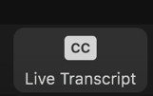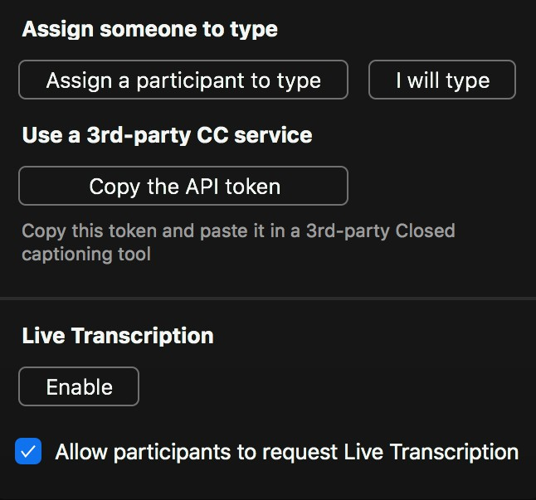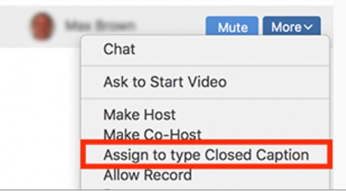

**Live Captions:** Hover over participants name and click more to assign them to type.

**Manual:** In Zoom click the closed captioning button then assign someone to type.

1. When captionist use a third-party service to display the captions (ex: Streamtext) this will display captions on a separate window and serves as a workaround if you are having difficulties with the zoom captions. **You must share the link provided by the Captionist with the attendees so that they can access the transcript.** The StreamText generated captions can also display within Zoom if you use the API token. To use API token, Click on **Copy API Token** and share with Captionist.
2. Live Transcription. This option is the Zoom generated captions.